**Restaurant Management System**

**Team Members :**

* Mahmoud Mamdouh Abd Allah [sec 16 , 2016170403]
* Mahmoud Youssef Mohamed [sec16 , 2017170415]
* Mayar Khaled [sec 17, 2017170464]
* MennatAllah Ibrahim [sec 17 , 2017170446]
* MennatAllah Sherif [sec 17 , 2017170447]

**TA : Nourhan Khaled**

**Flow Chart**

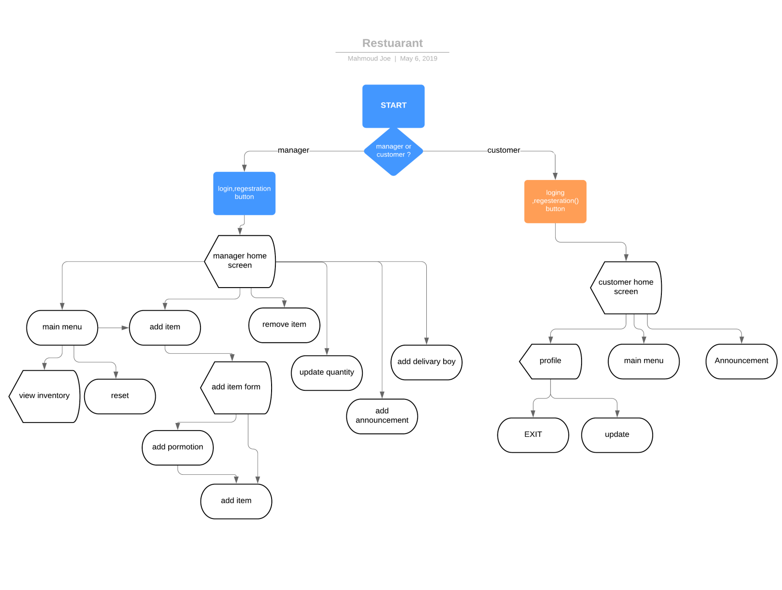

Class UML diagram

